**SOFTWARE DETAIL DESIGN**

***Group 5 includes:***

1. Lê Thị Thu Hà
2. Thân Thị Trang
3. Dương Nam Phương
4. Nguyễn Hữu Phước
5. Đặng Xuân Thành
6. Lê Xuấn Thành

***Content***

1. Architecture Style
2. Design Pattern
3. UML Diagrams
4. Use Case Diagram
5. Class Diagram
6. Activity Diagram
   * + Booking Function
     + Login Function
     + Create Trip Function
     + Update Trip Function
     + Delete Trip Function
     + Create Route Function
     + Delete Route Function
     + Create Station Function
     + Update Station Function
     + Delete Station Function
7. **Architecture Style**

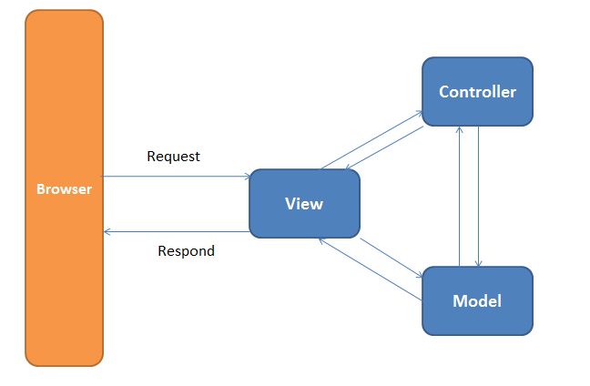

**MVC Model**

1. **Design Pattern**

**Mediator Pattern**

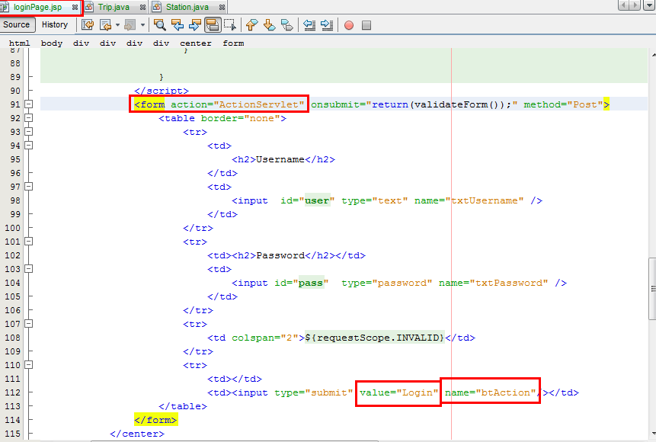

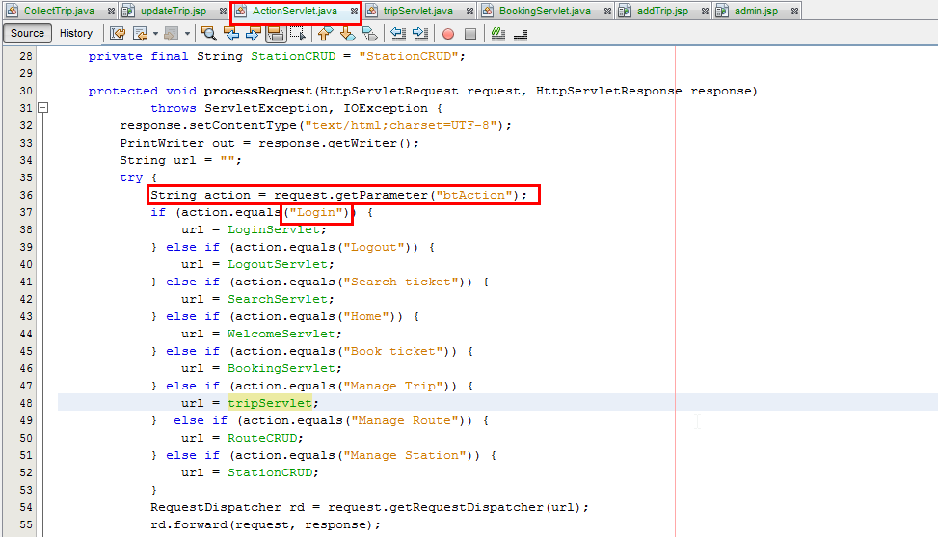

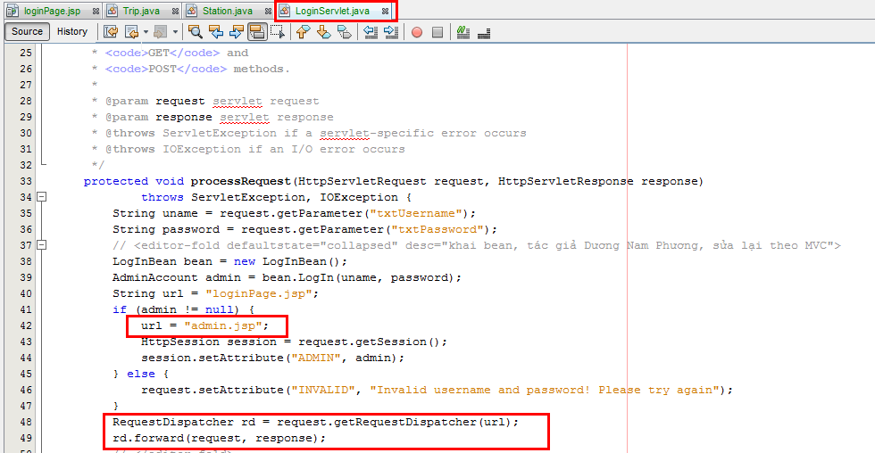

1. **UML Diagrams**
   * + 1. Use case Diagram

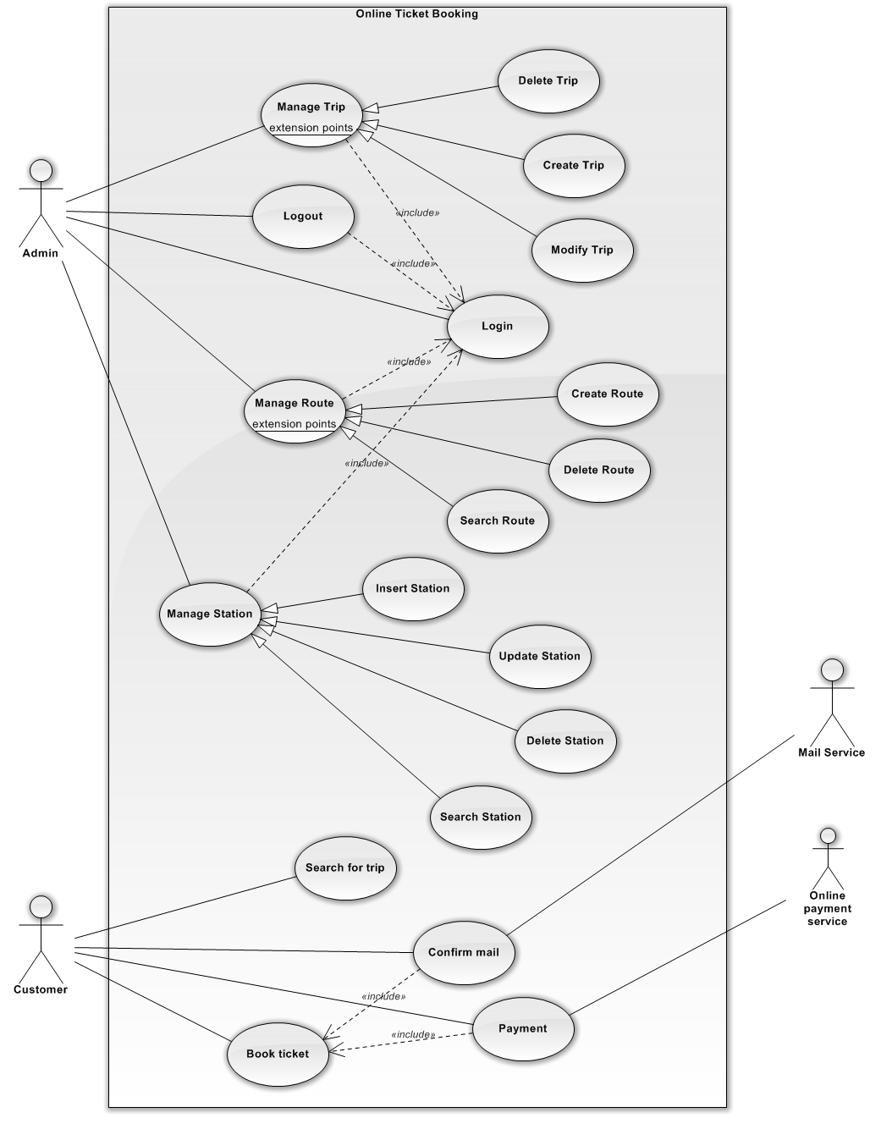

* + - 1. Class Diagram

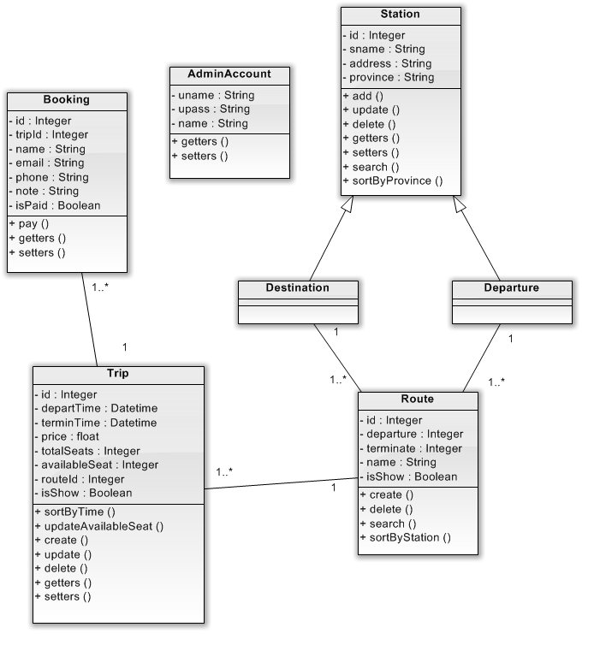

* + - 1. Activity Diagram

**Booking Function**

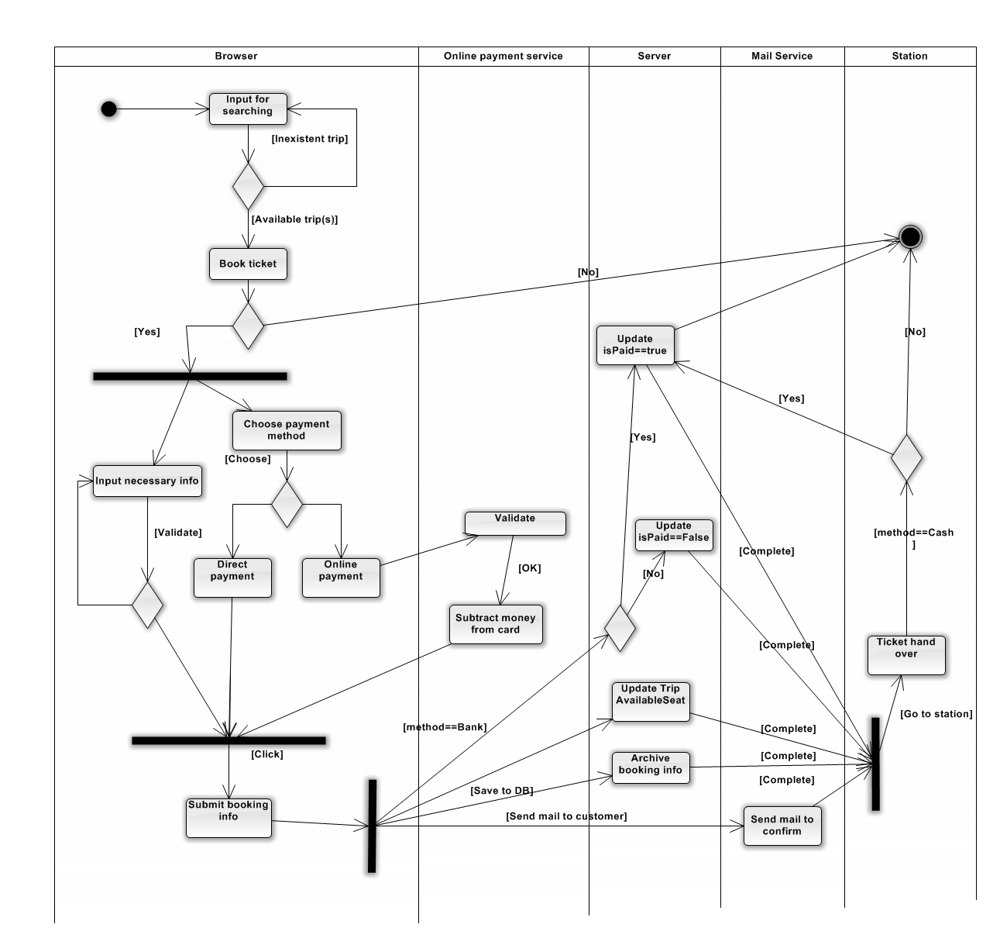

**Login Function**

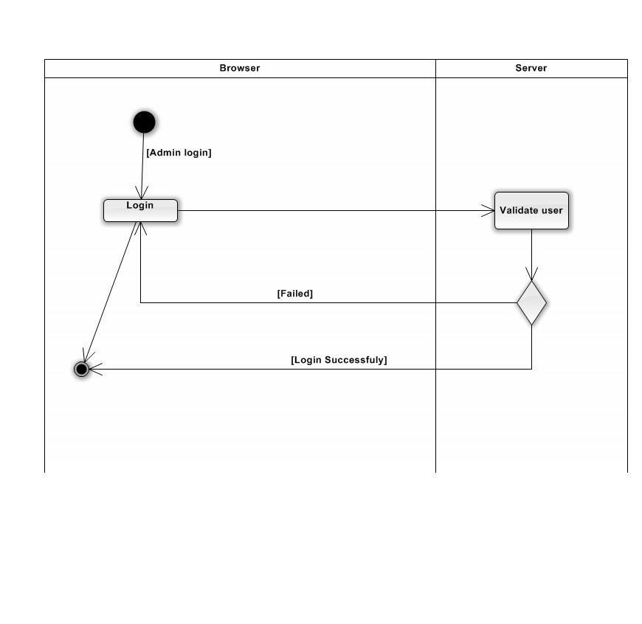

**Create Trip Function**

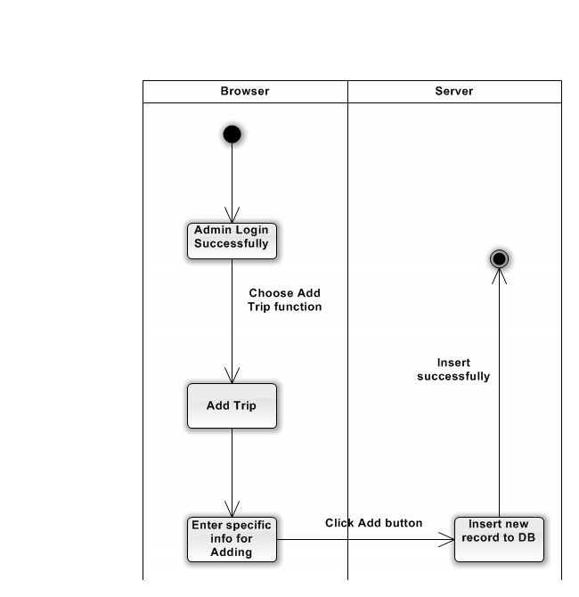

**Update Trip Function**

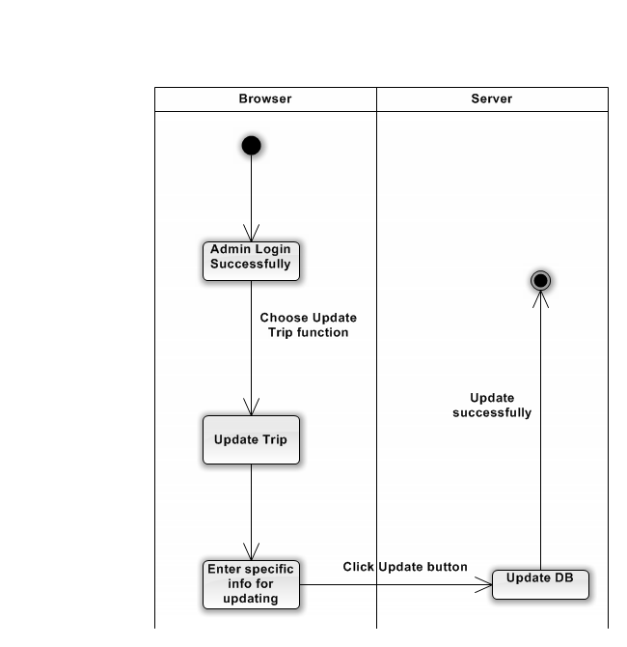

**Delete Trip Function**

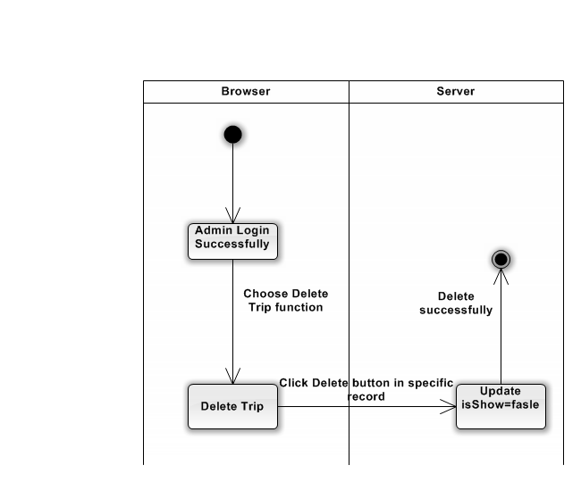

**Create Route Function**

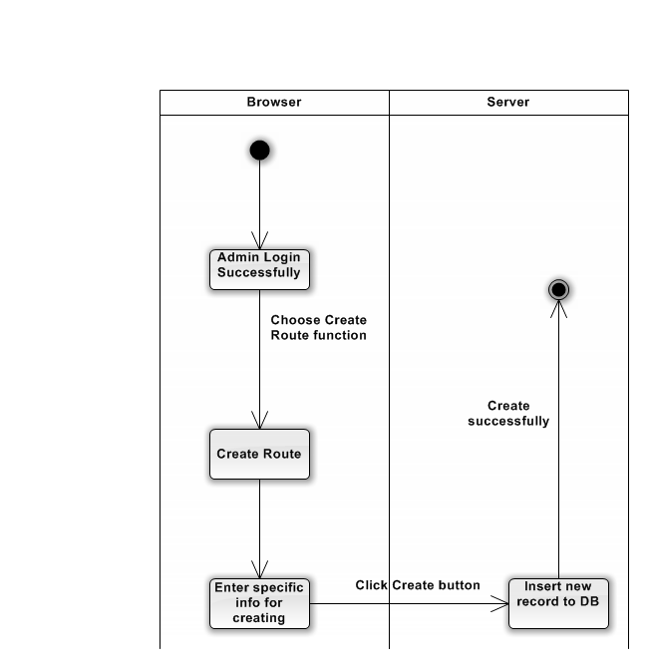

**Delete Route Function**

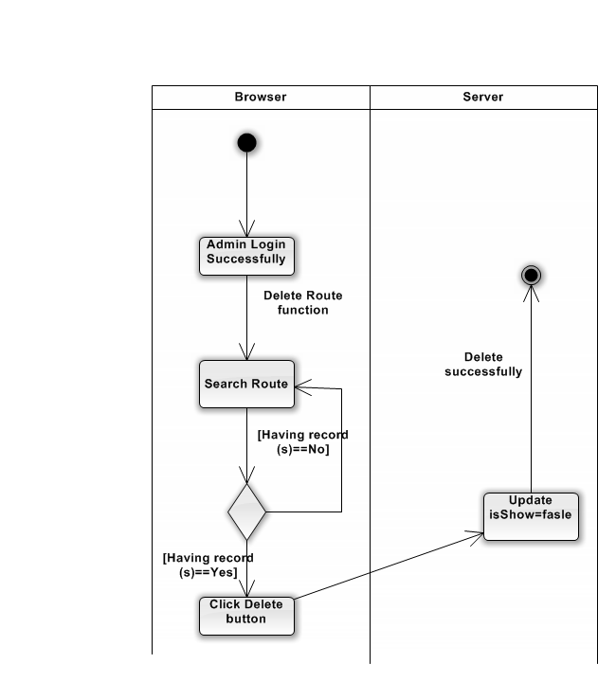

**Create Station Function**

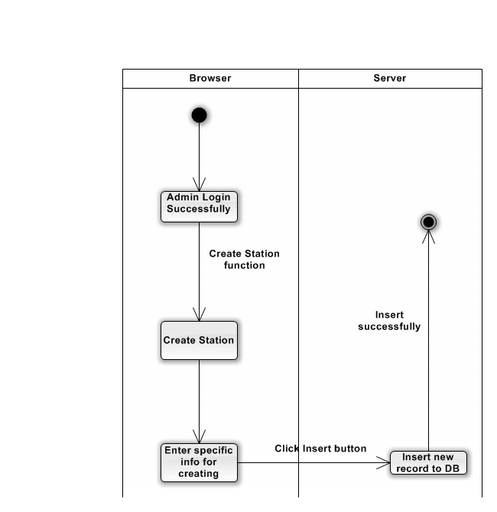

**Update Station Function**

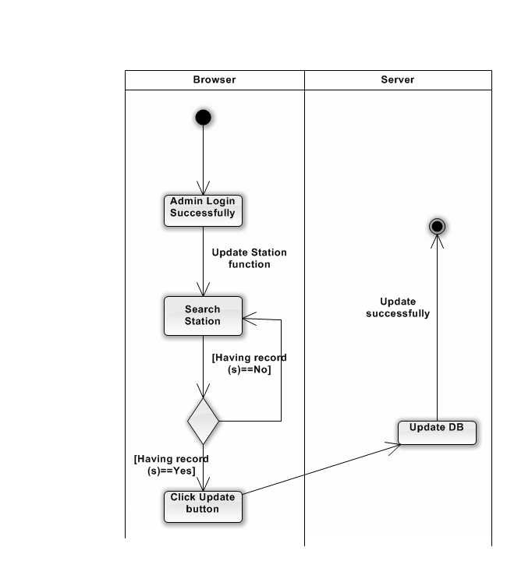

**Delete Station Function**

